**Project Design Phase-II**

**Data Flow Diagram & User Stories**

|  |  |
| --- | --- |
| Date | 03 October 2022 |
| Team ID | PNT2022TMID02435 |
| Project Name | Project – Detecting Parkinson’s Disease using machine learning |
| Maximum Marks | 4 Marks |

**Data Flow Diagrams:**

A Data Flow Diagram (DFD) is a traditional visual representation of the information flows within a system. A neat and clear DFD can depict the right amount of the system requirement graphically. It shows how data enters and leaves the system, what changes the information, and where data is stored.

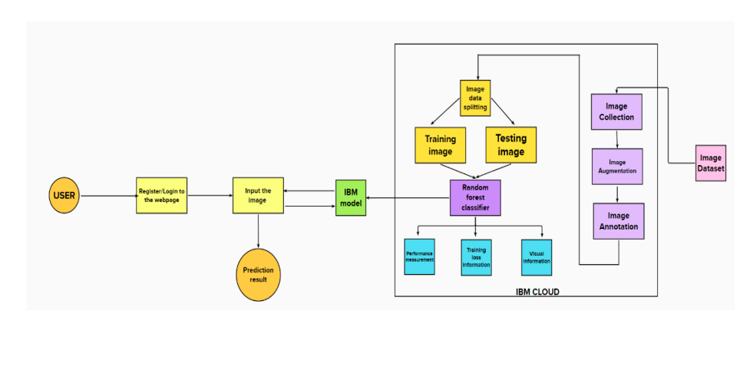

**User Stories**

Use the below template to list all the user stories for the product.

| **User Type** | **Functional Requirement (Epic)** | **User Story Number** | **User Story / Task** | **Acceptance criteria** | **Priority** | **Release** |
| --- | --- | --- | --- | --- | --- | --- |
| Customer (Web user) | Homepage | USN-1 | Description about Parkinson's disease. | I can get an idea about the disease | Low | Sprint-3 |
|  |  | USN-2 | Details about the test vitals required for the testing. |  | Low | Sprint-3 |
|  | Registration | USN-3 | As a user, I can register for the application by entering my username, email, phone number, and password, and confirming my password. | I can access my account | moderate | Sprint-3 |
|  |  | USN-4 | As a user, I will receive a confirmation mail once I have registered for the application. | I can receive a confirmation OTP upon registration for verification. | High | Sprint-3 |
|  | Login | USN-5 | As a user, I can log into the Web application by entering email & password | I can log in successfully. | High | Sprint-2 |
|  | Main page (Test vitals) | USN-6 | As a user, I submit the required image for the prediction. | I can access the page and can submit the input. | Moderate | Sprint-4 |
| Admin | Data collection | USN-8 | Collect the required data for the detection of Parkinson's disease |  | High | Sprint-1 |
|  | Data preprocessing | USN-9 | Clean and analyze the data to avoid noise and duplications | As a result I get the desired dataset to get trained. | High | Sprint-1 |
|  | Model Building | USN-10 | Build the model using a Random forest classifier to classify the images. | Successfully trained the model. | High | Sprint-1 |
|  | Deploy the model | USN-11 | Deployment of ML model using IBM Watson Studio, object storage. | Deployed successfully. | High | Sprint-2 |
|  | Integrate the web app with the IBM model | USN-12 | Use flask for the integration purpose. | Created the web app successfully. | Moderate | Sprint-2 |
|  |  |  |  |  |  |  |